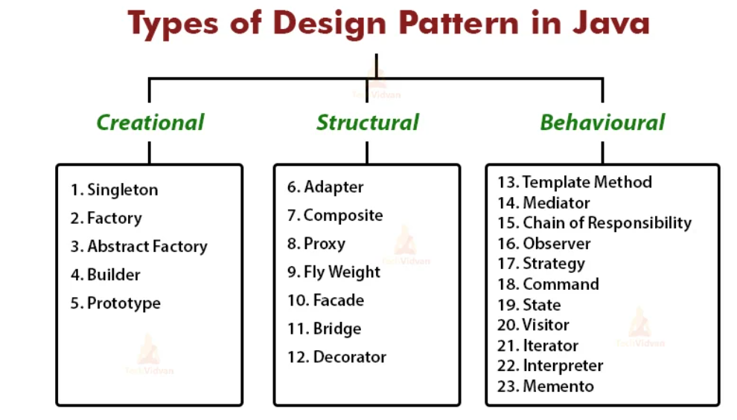

**Creational design** patterns work on the creation of the object. They provide a solution for instantiating an object in the best possible ways. We use Creational patterns often in place of direct instantiation with constructors.

**Structural design** patterns provide ways to create a class structure. For example, creating a large object from smaller ones using inheritance and composition.

Structural design patterns show us how to connect different pieces of a system together in a flexible and extensible manner. These patterns also guarantee that when one of the parts changes, the entire application structure does not need to change.

Structural patterns are the patterns that deal with the composition of objects and answer questions like:

* What is the content of the class?
* What is the relationship between a class with other classes?

**Behavioral patterns** deal with the behavior of objects, interactions between objects. How does an object communicate with other objects?

**Top 5 Popular Software Design Patterns in 2022**

* Creational/Singleton.
* Decorator.
* Command Design Pattern.
* Factory Design Pattern.
* The Observer Pattern.